**CP Club 365 Days Challenge**

**Programming language – C++**

**Problem Statement**

<https://www.interviewbit.com/problems/stairs/>

Git :- <https://github.com/Vedantbharad2603/CP_club_365_Days>

**Your Code**:

// 0x107Day of 0x365Days challenge

// VEDANT BHARAD

// 1-2-2023

#include <iostream>

using namespace std;

int stairs(int n)

{

    int a=0,b=1,sum=a+b;

    for (int i = 1; i <= n; ++i)

    {

        a = b;

        b = sum;

        sum = a + b;

    }

    return b;

}

int main() {

    int t;

    cin >> t;

    while(t--) {

        int A;

        cin >> A;

        cout<<stairs(A)<<endl;

    }

    return 0;

}

**Output (Screen Shot)**:

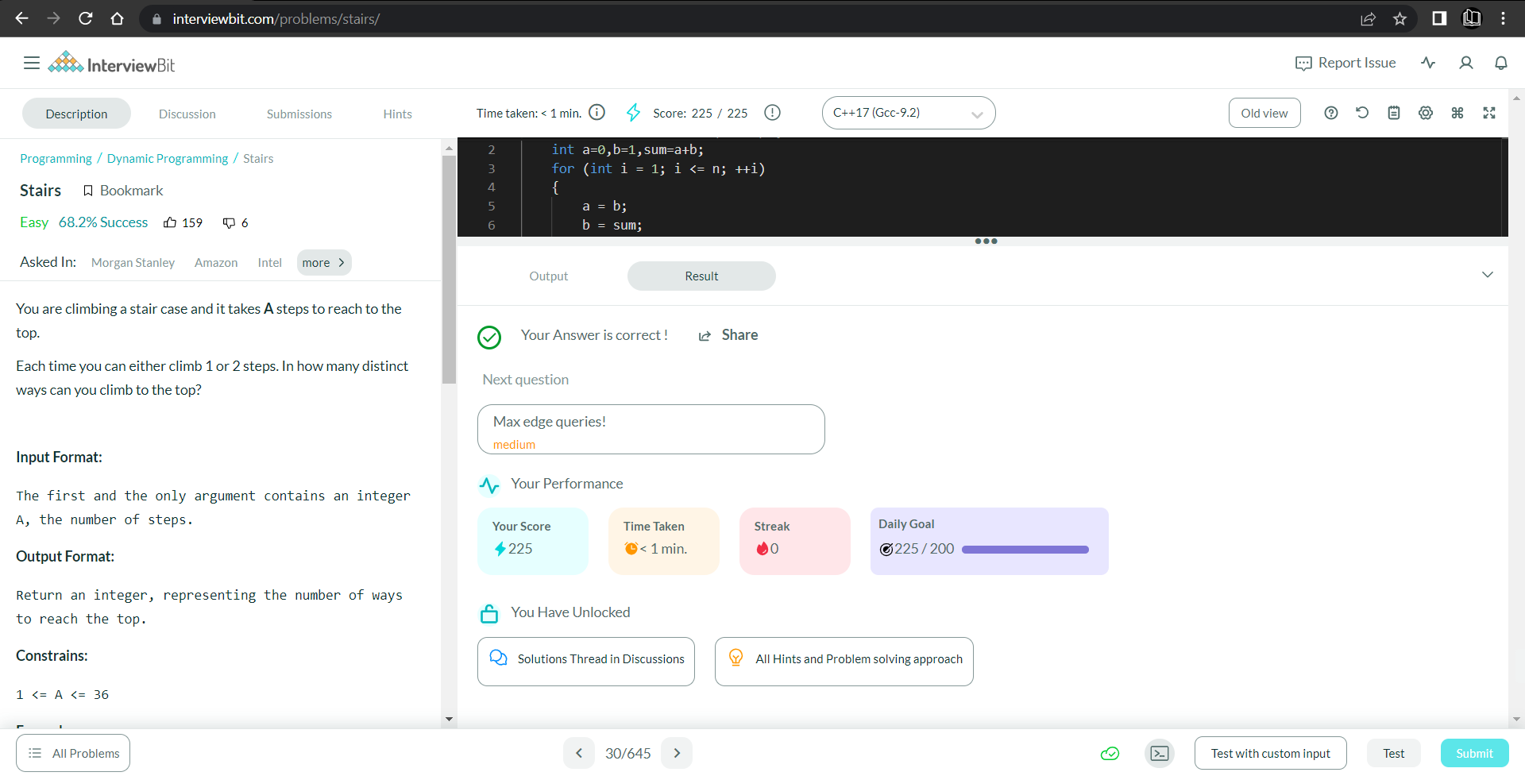

**Understanding about problem:**

* In this task I need to find ways to climb the stairs for A number of stairs so just return A+2th number of fibonacci series.

Note: If you can't understand the problem, feel free to contact us and we'll help you. Please don't copy and paste from anywhere.

ALL THE BEST

Team CP Club